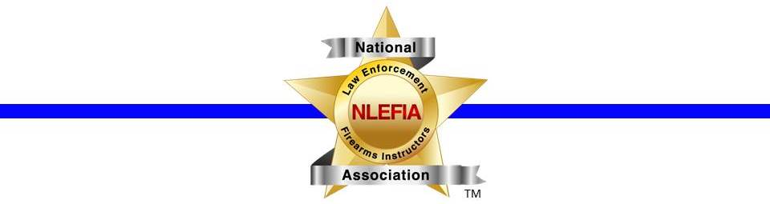

Product Evaluation Program
Manufacturer Application
Manufacturer

Website
Point of Contact

Phone

Email

Mailing Address

Product / Model # | Serial Number | MSRP

Please read and sign the second page. Submit both pages.

The manufacturer understands the following:
- NLEFIA will identify a volunteer member(s) to conduct the evaluation
- NLEFIA will send the evaluator's contact information to the manufacturer
- The manufacturer will ship the product directly to the evaluator
- The evaluator will have the product for a period of 30-45 days to conduct the evaluation
- The evaluator will NOT be held liable for any damage to the product as part of the evaluation process
- At the conclusion of the evaluation, the evaluator with send the product back to the manufacturer along with a professional report of the findings of the evaluation. A copy of the report will also be sent to NLEFIA.
- The product will be graded in ten different categories, or in as many categories that apply to the product. The 10 categories are listed on the NLEFIA website
- Each category with be rated on a scale of 1-5 stars. The definitions of each rating is posted on the NLEFIA website
- The evaluator(s) will also provide a written / typed detailed review of the product
- NLEFIA reserves the right to publish the product evaluation report in the quarterly magazine, The Rangemaster, for other members to read.

POC Signature: _____________________________________ Date: ______________

Special requests by the manufacturer:

